Static website hosting in s3 using external DNS:
Note:- While creating s3 bucket we need create the bucket name with external DNS name.
Eg: My DNS name is maitesworld.com so my bucket name will be maitesworld.com.
To create a static website hosting in s3 using external DNS we need to configure in 3 areas
- S3 bucket
- External DNS configuration.
- Route 53 Hosted zones
S3 bucket:-
To host a static website, First we need to create a S3 bucket with public access.
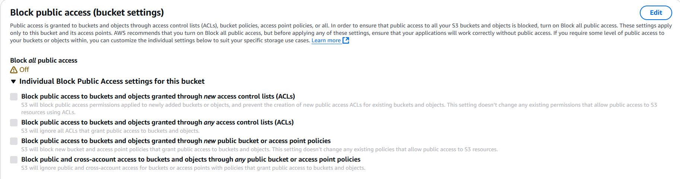
We need to define the bucket policy in permission session, which are all permissions are allowed and inside the bucket what are all objects we can access.
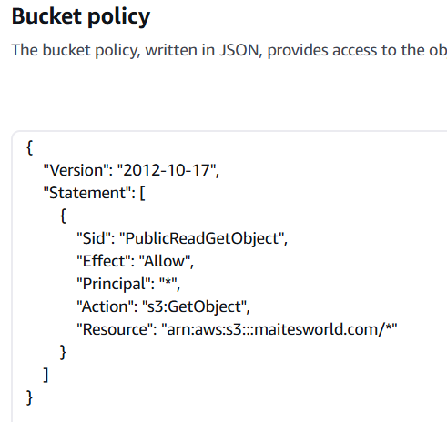
Enable the static website hosting in properties session and define below mentioned values as it’s.
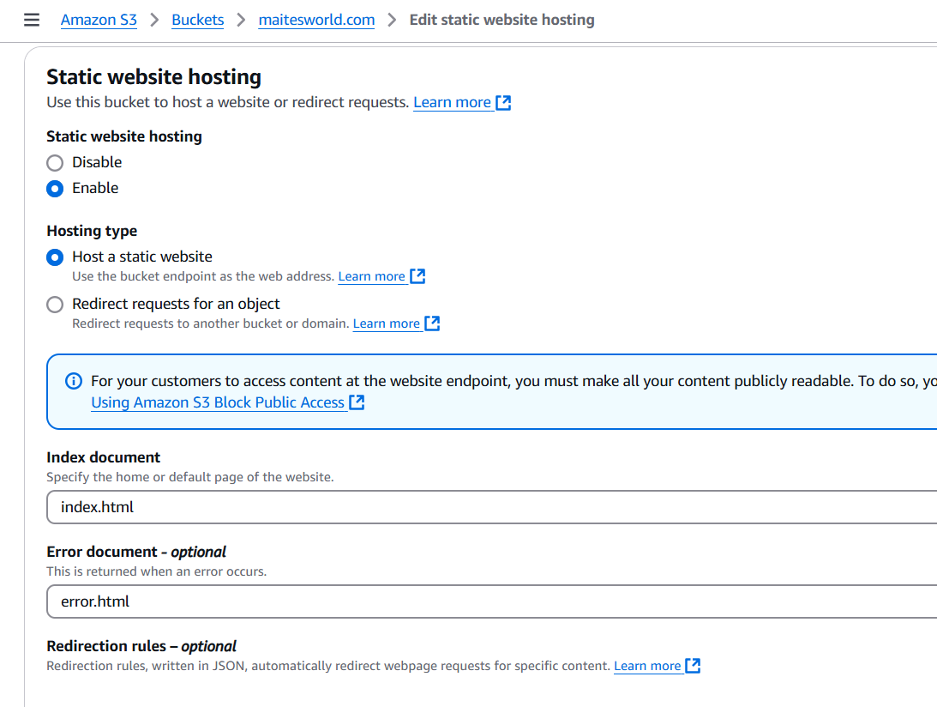

Route53 Hosted zone:-
Go to Route53 -> hosted zone and add your website DNS eg: maitesworld.com and select public hosted zone and save it.
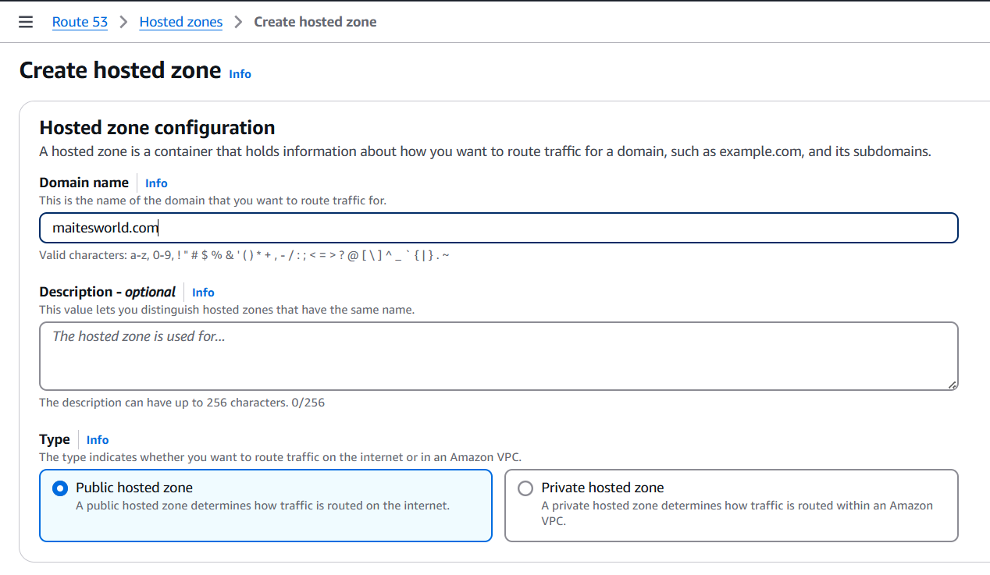
It will create below records
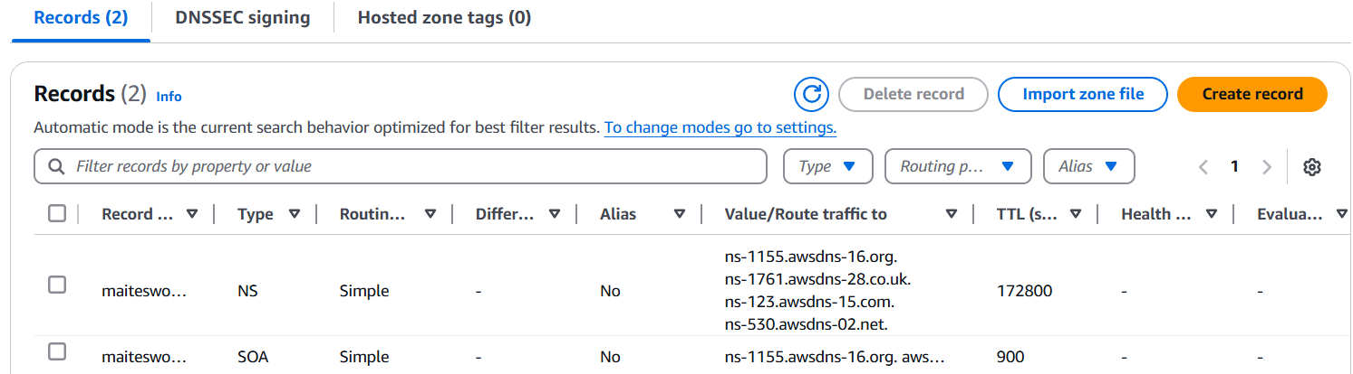
If we observe Nameservers are having 4 values we will use these in “External DNS configuration”.
Now, click on create record select A or NS and enable alias give below details.
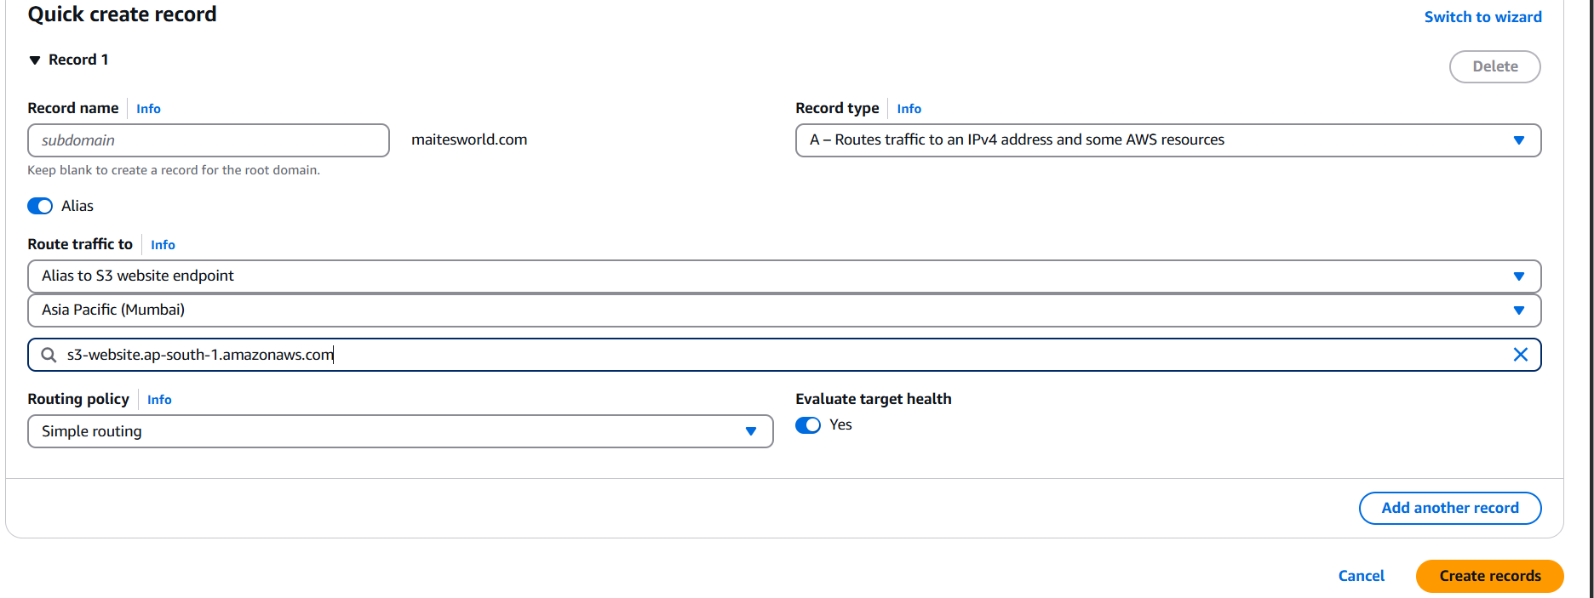
While configuring s3 we need to select the route traffic there ‘Alias to s3 website endpoint’ and then region while selecting the bucket it should pre-populate. If it’s not pre-populated then we need to cross check the bucket name. The bucket name and the External DNS name should be same and click on create records.
External DNS configuration:-
Go to go daddy. If you don’t have any DNS create it the select the DNS go to DNS session
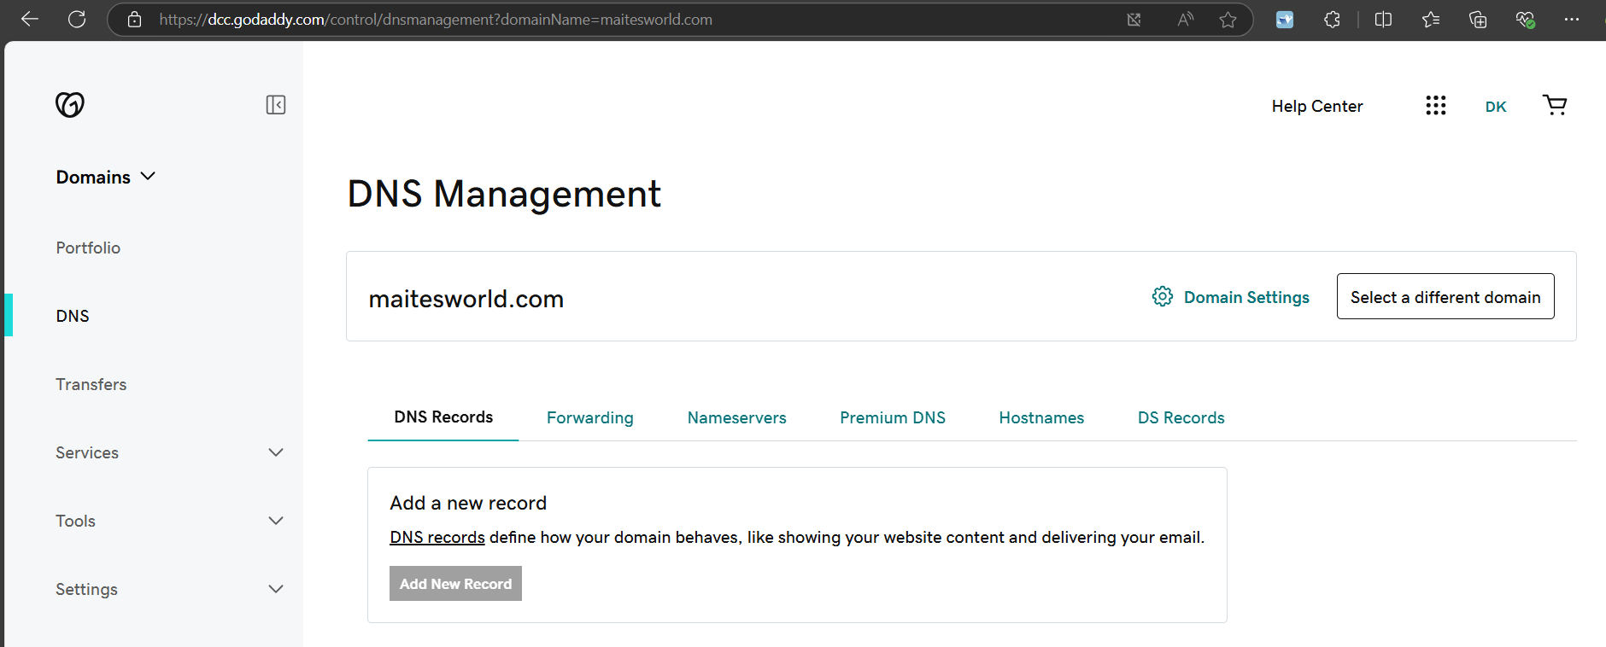
Go to Nameservers tab whatever we have collected 4 NS values in Rout53 hosted zones we need to configure like below by clicking on nameservers.
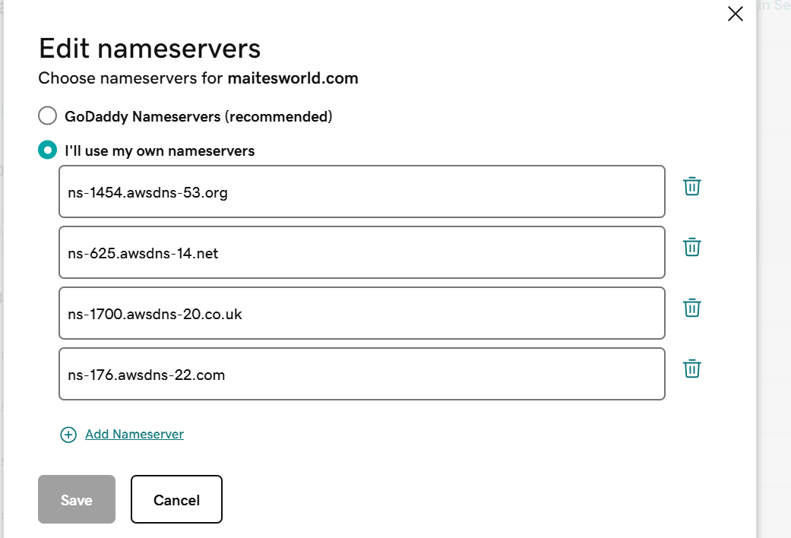
After changing the namespaces it will take 1-48 hrs. For me it got reflected immediately.Meantime you can test these in https://www.whatsmydns.net/ . Open the site select ‘NS’ and add our DNS name and click on search if we have configure correctly our DNS record values from Route53 will show you like below.
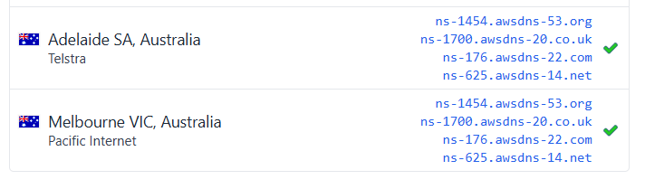
Don’t forget to add index.html file to s3 bucket. My index.html will show the picture of mine while search for maitesworld.com.
My script:-
<!DOCTYPE html>
<html lang="en">
<head>
<meta charset="UTF-8">
<meta name="viewport" content="width=device-width, initial-scale=1.0">
<title>My Image</title>
</head>
<body>

</body>
</html>

